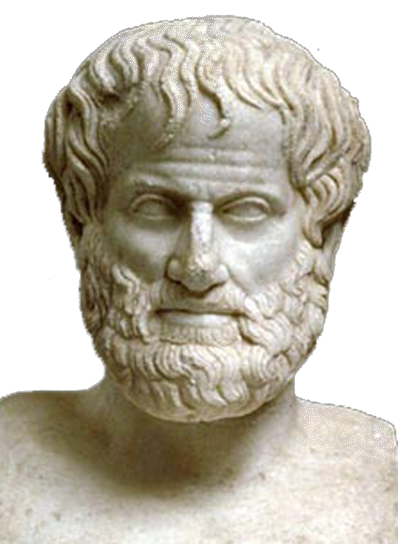 | World Congress in Philosophy (WCP 2016)  The Philosophy of Aristotle  Athens, 10-15 July 2016  School of Philosophy, National & Kapodistrian University of Athens, Greece

Template Form N. 4 for Abstract & Paper (31 sections)
(All fields marked with * should be completed and written in English to avoid technical problems)
1) I HAVE SUBMITTED PARTICIPATION FORM No 1: □ Yes
Country:
* Last (Family) Name:
* First (Given) Name (Mr., Mrs., Ms.):
* Title: □ Prof. □ Dr. □ MPhil. □ MA □ BA:
* Affiliation—Institution (Teaching or Research):
* E-mail Address:
2) Please note that the duration of speaking time is 20΄ minutes
3) SECTION OF PAPER: (Please check the appropriate name of section for which your paper is intended. See the 31 sections for contributed papers)
4) ABSTRACT (a maximum of 500 words-keywords included)
5) PAPER (Please see the relevant note in the First Circular)
6) Please send this form as it is (i.e. not as PDF) to the following email address: secretariat@iagp.gr

Follow pattern
Section:
Author(s): Papadopoulou Maria
Title of paper: Philosophy as a way of life according to Aristotle

Abstract and key-words (500 words)
………………………………………………………………………………………………………………………………………………………………………………………………………………………………………………………………………………………………………………………………………………………

Text of the paper:
…………………………………………………………………………………………………………..……….…………………………………………………………………………………………………………………...…………………………………………………………………………………………………………………...
At the end of the text, insert Author’s details and email:
[Dr. Maria Papadopoulou
Assistant Professor of Philosophy
Department of Philosophy
University of Athens
Hellas
Email:

